

HackerRank Grade Report

Name : Richard Chingshubam
Enrollment ID : ADTU/1/2025-28/BCAO/002
Semester : 2
Sec : C
Previous Semester Hackos point Screenshot :
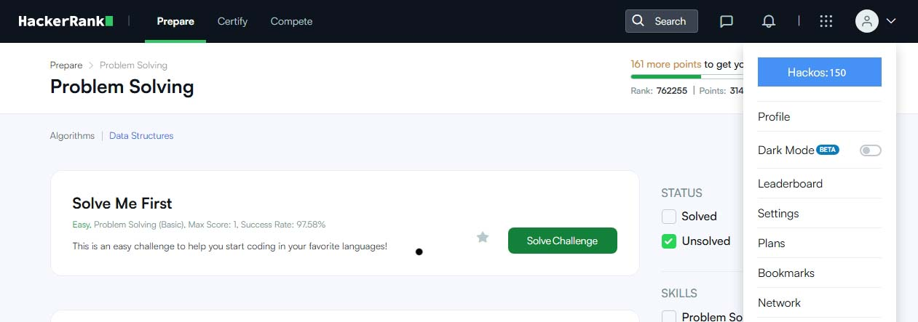

Current Semester Hackos point :

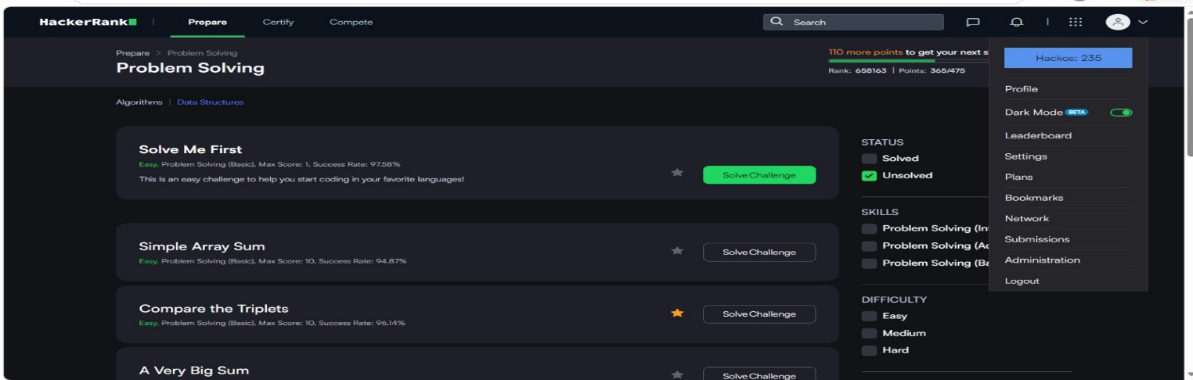

Rank : 654587
Point : 365
Rank and Point Screenshot :
